|  |  |
| --- | --- |
| **TEAM ID** | **PNT2022TMID51168** |
| **PROJECT NAME** | **Exploratory Analysis Of Rain Fall Data In India For Agriculture** |

**PROJECT FLOW :**

To accomplish this, we have to complete all the activities and tasks listed below

Data Collection

* Collect the dataset orCreate the dataset

Data Pre-processing ● Import theLibraries.

* Importing thedataset.
* Checking for NullValues.
* Data Visualization.
* Taking care of MissingData.
* Label encoding.
* One Hot Encoding.
* Feature Scaling.
* Splitting Data into Trained Test.

Model Building

* Training and testing themodel
* Evaluation ofModel

Application Building

* Create an HTMLfile
* Build a PythonCode

**Diagram:**

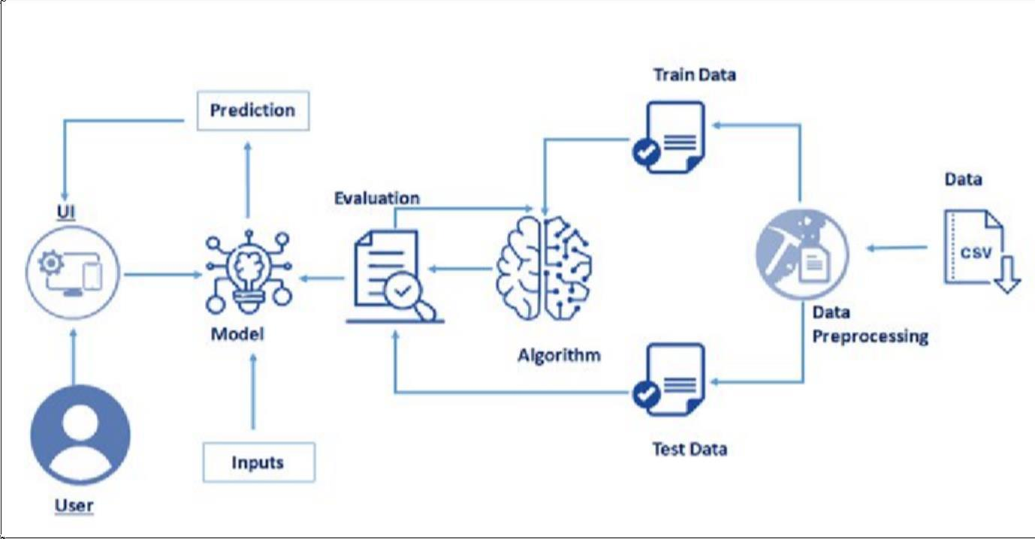

**Final Output:**

* User interacts with the UI (User Interface) to enter the input values
* Entered input values are analyzed by the model which isintegrated
* Once the model analyses the input the prediction is showcased on the UI